**UNIVERSITY INSTITUTE OF COMPUTING**

**MASTER OF COMPUTER APPLICATIONS(AI & ML)**



**Project Report**

**DATA ANALYTICS**

**23CAH-721**

**Project Title**

**COVID-19 Dashboard: Tableau Visualization**



**Submitted To :**  **Submitted By:**

Mr. Krishan Tulli 23MCI10069

**Introduction & Project Objectives**

**Introduction**

The COVID-19 pandemic has significantly impacted global health, economies, and daily life. In this context, effective data analysis and visualization have become crucial for understanding the spread of the virus and the effectiveness of response measures. This project focuses on creating an interactive dashboard using Tableau to visualize critical COVID-19 related data.

The primary objective of this project is to provide a comprehensive overview of key COVID-19 metrics, including statewise testing details, vaccination doses administered, and demographic distributions of vaccinated individuals. By visualizing data on testing rates, vaccine administration, and demographic factors such as age and gender, we aim to identify trends and insights that can aid policymakers and health organizations in making informed decisions.

The dashboard encompasses various visualizations, including bar charts, donut charts, and comparative analyses of first and second doses administered across different age groups and genders. Through this project, we seek to enhance our understanding of the pandemic's impact and support ongoing efforts to mitigate its effects.

**Project Objectives**

**1.Data Visualization:** To create an interactive dashboard that effectively visualizes COVID-19 related data, making it accessible and understandable for stakeholders and the general public.

**2.Statewise Analysis:** To analyze statewise testing details, including the number of positive, negative, and total samples tested, to identify trends and disparities in testing efforts across different regions.

**3.Vaccination Insights:** To visualize the total doses administered for different vaccines (Covishield, Covaxin, Sputnik V) and compare the uptake of first and second doses across various demographics.

**4.Demographic Breakdown:** To examine vaccination data by age group and gender, providing insights into which populations are receiving vaccinations and identifying any gaps in coverage.

**5.Inform Policy Decisions:** To provide actionable insights and trends derived from the visualized data that can assist policymakers, health organizations, and researchers in making informed decisions regarding resource allocation and public health strategies.

**6.Enhance Public Awareness:** To raise awareness about COVID-19 testing and vaccination efforts, helping the public understand the importance of participation in these initiatives.

**Data Sources & Download Process**

**Data Sources**

For this project, the primary data source is theKaggle platform, which hosts a wide array of datasets related to COVID-19. Specifically, we utilized datasets that provide comprehensive information on testing rates, vaccination statistics, and demographic breakdowns of COVID-19 cases across various states in India. The Kaggle datasets are sourced from reputable organizations, ensuring the accuracy and reliability of the information used for analysis.

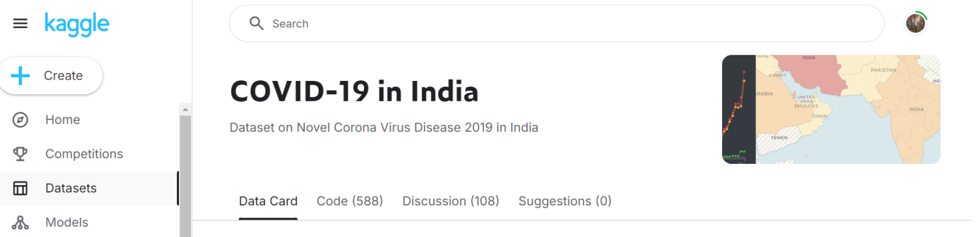

**Download Process**

**1.Accessing Kaggle:**

The first step involved navigating to the Kaggle website and searching for COVID-19 datasets. This was done by entering relevant keywords in the search bar.

**2.Selecting the Dataset:**

After browsing the available datasets, we selected the most appropriate one that aligned with our project objectives. The chosen dataset contained essential information on testing, vaccination, and demographics.

**3.Downloading the Data:**

Once the dataset was selected, we clicked on theDownload button, which initiated the download process. The data was saved in CSV format to facilitate easy importing into data visualization tools.

**4.File Verification:**

After downloading, we verified the downloaded file to ensure that it contained all necessary data points and was free of errors.

**5.Importing into Tableau:**

The final step in the download process involved importing the CSV file into Tableau for analysis and visualization. This process included selecting the file from our local directory and confirming the data structure during import.

**Datasets**

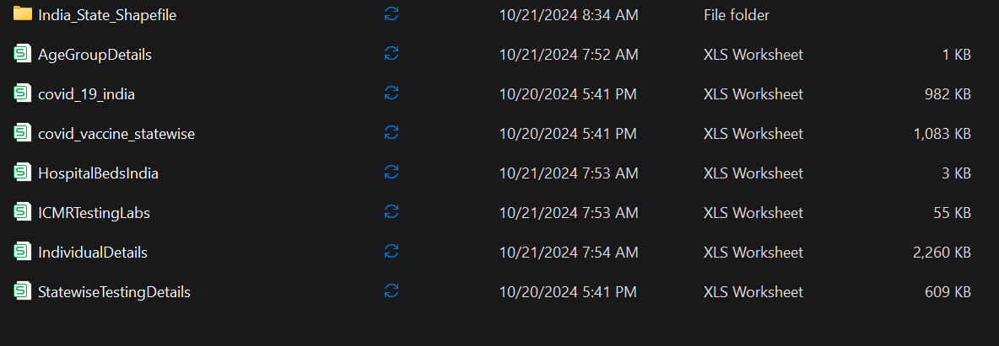

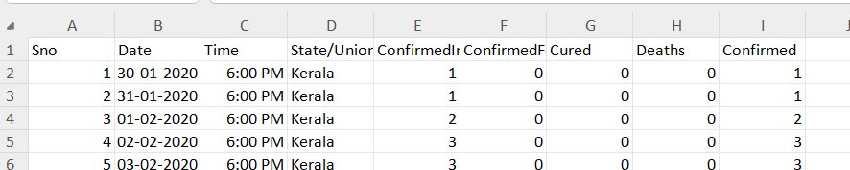

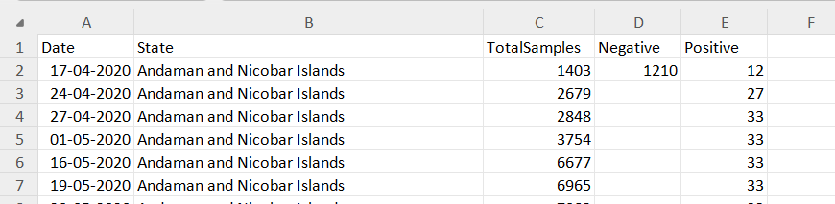

**Insights and Common Questions Addressed**

**Insights**

**1.Statewise Testing Trends:**

Significant disparities were observed in testing rates across different states. States with higher testing rates generally exhibited lower positivity rates, indicating more effective testing strategies.

**2.Vaccination Coverage:**

The analysis revealed a steady increase in vaccine doses administered, withCovishield being the predominant vaccine. The gap between first and second doses suggests a need for targeted campaigns to ensure complete vaccination.

3**.Demographic Insights:**

Data indicated that older adults (60+) were the most vaccinated demographic, reflecting targeted efforts for vulnerable populations. However, younger age groups (18-30) showed lower vaccination rates, indicating the need for enhanced outreach.

**4.Gender Distribution in Vaccination:**

The gender analysis demonstrated a balanced vaccination distribution, with slight variations in specific age groups, suggesting potential differences in vaccine uptake between genders.

**5.Impact of Testing and Vaccination:**

The data suggests a positive correlation between increased vaccination rates and decreased COVID-19 cases, highlighting the effectiveness of vaccines in controlling the virus spread.

**Common Questions Addressed**

**1.What are the current testing rates in different states?**

The dashboard provides a clear visual representation of testing rates, showcasing states that excel in testing efforts and identifying areas for improvement.

**2.How effective are vaccination campaigns in different demographics?**

Insights into vaccination rates across age and gender groups help identify demographics needing additional focus in vaccination efforts.

**3.What are the trends in vaccine administration over time?**

The dashboard tracks vaccination trends, illustrating the rollout of different vaccines and highlighting periods of increased administration.

**4.How do vaccination rates correlate with COVID-19 case numbers?**

The analysis explores the relationship between vaccination rates and reported COVID-19 cases, providing evidence for the vaccines' effectiveness in reducing infections.

**Multiple Line Chart and Horizontal Bar Charts**

**Case Trends over Time**

Line charts visualize the trend of confirmed cases, deaths, and recoveries over time, allowing users to identify patterns and understand the pandemic's evolution.

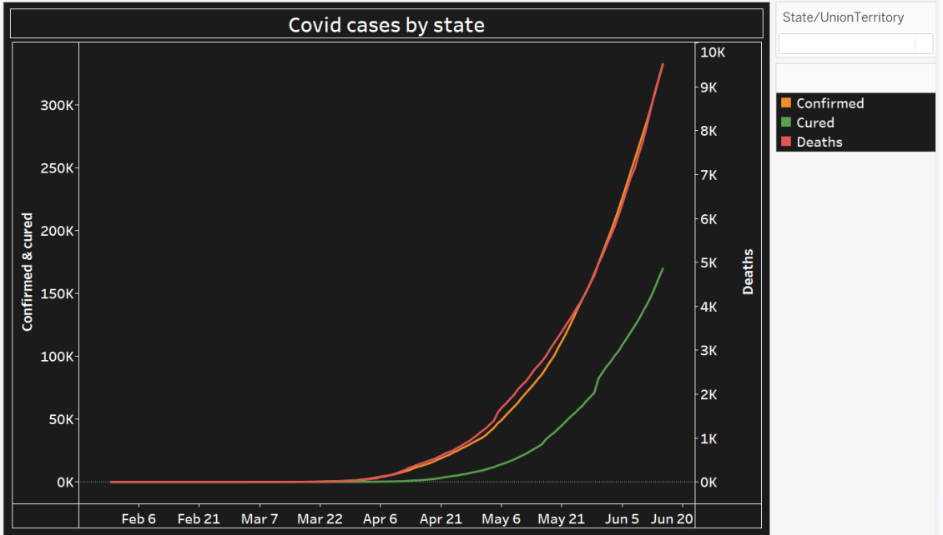

**Comparison of Key Metrics**

Horizontal bar charts provide a visual comparison of key metrics, such as case fatality rate, testing rate, and vaccination coverage across different regions.

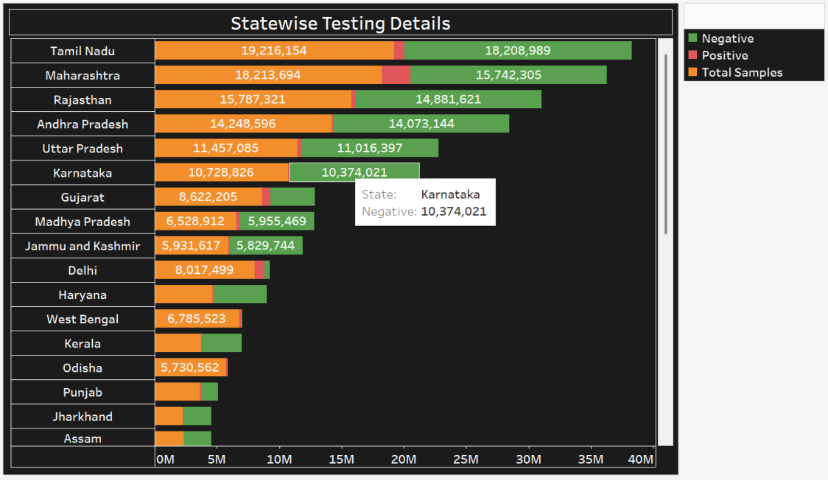

**Donut Charts**

**Age Group Details**

This donut chart shows the distribution of COVID-19 vaccinations across different age groups. It highlights the proportion of doses administered to each age category, helping to understand which age groups have the highest and lowest vaccination coverage. This visualization provides quick insights into the demographic impact of the vaccination drive.



**Gender without missing values**

This donut chart illustrates the gender-wise distribution of COVID-19 vaccinations, excluding any missing values. It provides a clear breakdown of doses administered to male and female individuals, helping to understand the gender balance in the vaccination process.



**Bar Chart**

**Statewise Testing Details**

This bar chart displays COVID-19 testing data for each state, showing the number of Negative, Positive, and Total Samples Tested. It provides a clear comparison of test outcomes, helping to understand the testing distribution and positive case trends across states.

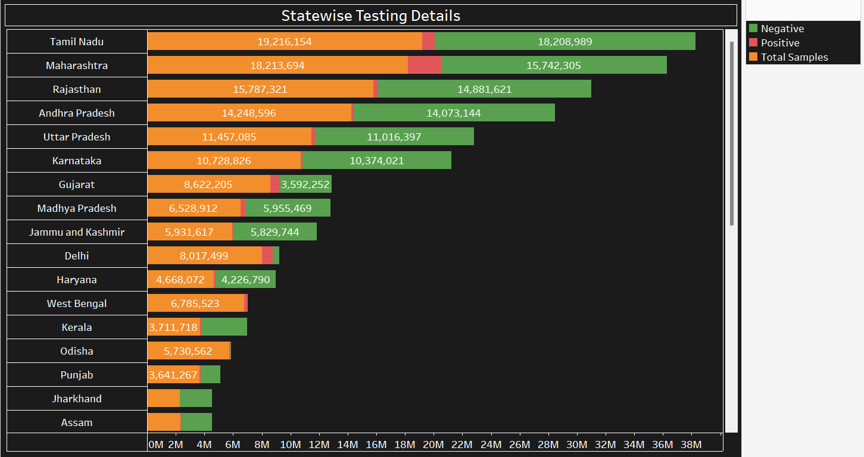

**ICMR Testing Labs in Each State**

This chart shows the distribution of ICMR testing labs across different states. It highlights the number of labs available in each state, providing insights into the testing infrastructure and capacity for handling COVID-19 cases.

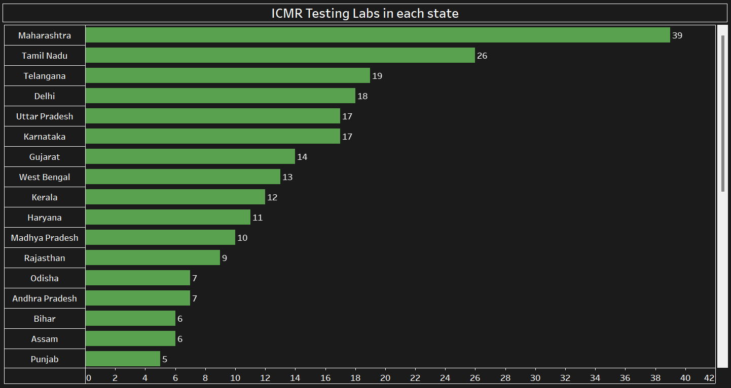

**Doses Administered by Vaccine**

This bar chart illustrates the total number of doses administered for three vaccines: Covishield, Covaxin, and Sputnik V. It provides a comparison of the vaccination efforts across these vaccines, highlighting their individual contributions to the overall immunization campaign.

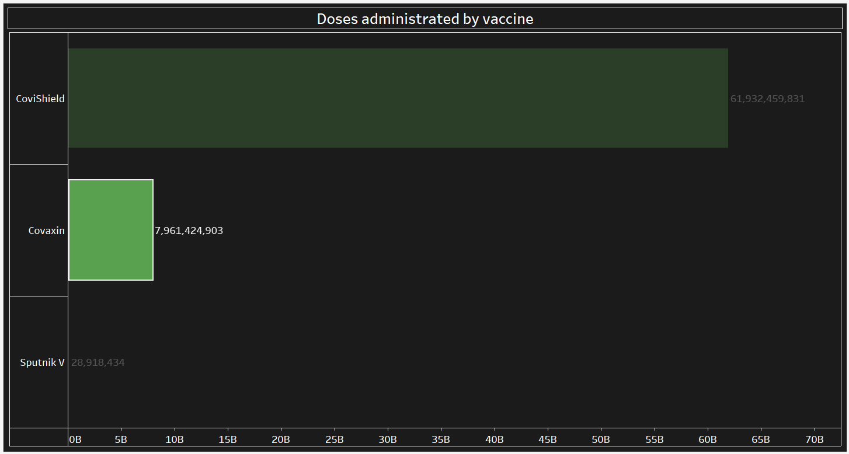

**First vs Second dose administrated**

This bar chart compares the total number of first and second doses administered during the COVID-19 vaccination campaign. It visually represents the progress in both initial vaccinations and follow-up doses, showing the overall vaccination coverage and completion rates across the population.

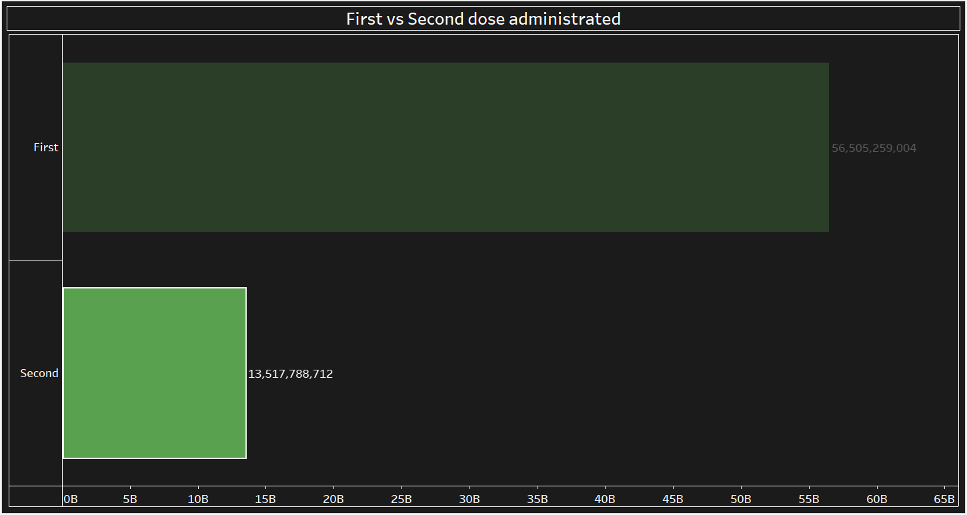

**Final Dashboard and User Interaction Features**

**Interactive Filters**

The dashboard incorporates interactive filters that allow users to customize their analysis. Users can filter data by:

**-Country:** Select specific countries to analyze their COVID-19 statistics, enabling comparisons across regions.

**-Region:** Focus on specific regions within a country, helping to identify localized trends and disparities.

**-Date Range:** Specify a date range to view data over a particular period, facilitating the analysis of trends and patterns over time.

**-Other Parameters:** Additional filters can be applied based on vaccination status, age groups, or testing rates, providing users with tailored insights.

These interactive filters empower users to explore specific trends that matter to them, making the dashboard a powerful tool for understanding the dynamics of the pandemic.

**Data Drill-Down**

The dashboard features a data drill-down capability, allowing users to explore specific regions or data points in greater detail. This feature enables:

**-Granular Analysis:** Users can click on specific data points (e.g., a state or age group) to reveal more detailed statistics and trends, enhancing their understanding of the pandemic's local impact.

**-Contextual Information:** Drill-downs provide access to contextual information, such as historical data and related metrics, helping users make informed decisions based on comprehensive insights.

This capability allows for a deeper exploration of the data, fostering a better understanding of the COVID-19 situation at various levels.

**Data Export Options**

To facilitate further analysis and research, the dashboard offers data export options. Users can export data in various formats, including:

**-CSV:** For easy import into spreadsheet applications for further analysis.

**-Excel**: For users who prefer working with data in a familiar spreadsheet environment.

**-PDF:** For generating reports that can be shared with stakeholders.

These export options enable users to conduct in-depth research and collaborate with others, ensuring that the insights gained from the dashboard can be utilized effectively beyond the initial analysis.

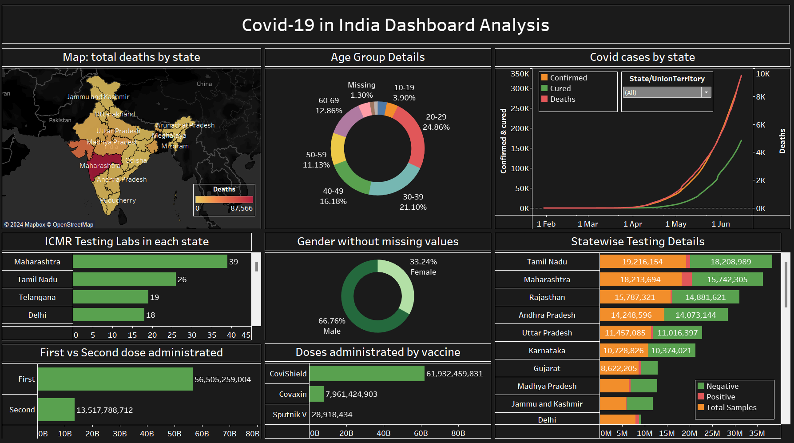

**Use Cases and Real-Time Data**

**Use Cases**

**1.Public Health Policy Making:**

Public health officials can utilize the dashboard to analyze COVID-19 trends and vaccination rates. By understanding which regions have low vaccination coverage or high positivity rates, policymakers can direct resources and implement targeted interventions to control outbreaks.

**2.Healthcare Resource Allocation:**

Hospitals and healthcare facilities can leverage the dashboard to assess local COVID-19 cases and vaccination rates. This information helps in efficiently allocating resources, such as vaccines and medical supplies, based on the areas most in need.

**3.Research and Academia:**

Researchers and academics can use the dashboard's data for studies on the effects of COVID-19 across different demographics. The ability to drill down into specific data points allows for in-depth analysis of factors influencing transmission, recovery, and vaccination outcomes.

**4.Community Awareness Campaigns:**

Non-governmental organizations (NGOs) and community health workers can use insights from the dashboard to design targeted awareness campaigns. Understanding which demographics are lagging in vaccinations helps tailor messages that resonate with those communities.

**5.Business Planning:**

Businesses can monitor COVID-19 trends in their regions to make informed decisions about reopening, employee safety measures, and customer engagement strategies. The dashboard provides insights into local case trends and vaccination progress, which are critical for business continuity.

**Real-Time Data**

The importance of real-time data cannot be overstated, particularly in a rapidly evolving situation like the COVID-19 pandemic. Key aspects of real-time data include:

**-Timeliness:**

Access to real-time data allows stakeholders to respond quickly to emerging trends, such as spikes in cases or changes in vaccination rates. This immediacy is crucial for effective public health responses.

**-Informed Decision-Making:**

Real-time data empowers decision-makers with current information, enabling them to adjust strategies and allocate resources efficiently. This capability is vital in ensuring that responses are appropriate to the current situation.

**-Trend Analysis:**

Continuous updates to the data facilitate ongoing trend analysis, allowing stakeholders to monitor the effectiveness of interventions over time. This information is essential for evaluating public health strategies and making necessary adjustments.

**-Community Engagement:**

Real-time data fosters transparency and community engagement by providing the public with up-to-date information. This accessibility encourages informed decision-making among individuals regarding their health and safety.

**Conclusion**

The COVID-19 dashboard serves as a vital resource for understanding and responding to the ongoing pandemic. Through comprehensive data analysis and visualization, the dashboard has illuminated key trends in testing, vaccination, and case management across various states and demographics.

The insights derived from the dashboard highlight the importance of targeted public health strategies, particularly in addressing disparities in vaccination rates among different age groups and regions. The interactive features, such as filters and data drill-down options, empower users to explore the data in a personalized manner, fostering a deeper understanding of the pandemic's local impact.

Moreover, the ability to export data facilitates collaboration and further research, making the dashboard an essential tool for policymakers, healthcare professionals, researchers, and community organizations.

In conclusion, as the pandemic continues to evolve, the COVID-19 dashboard stands as a crucial instrument for informed decision-making, enabling stakeholders to adapt strategies based on real-time data and emerging trends. By leveraging the insights gained from this analysis, we can work collectively towards improving public health outcomes and ultimately overcoming the challenges posed by COVID-19.